# Sizing units

## px:

This is a pixel unit. It is 1/96 of an inch.

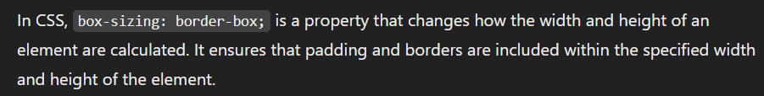

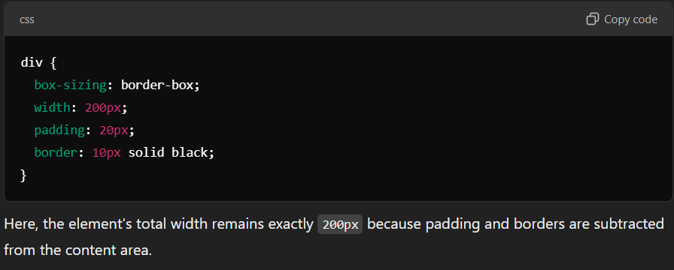

## vw/vh (must use these only most of the time)

This stands for viewport width and height. They represent percentages of viewport (current display area’s dimension). They are useful to create responsive designs

1vh means 1% of viewport height

100vh and 100vw means full screen

150vw will create a horizontal scroll bar

margin: auto 🡪 this will center the block level elements; this means to put margin automatically on left and right.

This will not work on inline elements like span etc.

margin: 23px auto -> This is used to mention both vertical and horizontal margin separated by space (this is called margin shorthand property)

## em

For a particular element if it was going to inherit 18px from its parent then now it the child element if I put font-size: 2em. Then the inherited font size will be 36px.

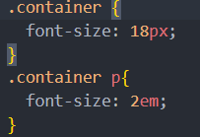

## rem

Just like em. But here instead of multiplying with parent font size, it is multiplied with root font size.

Default font size of root is 16px. You can redefine it like this in style tag in head

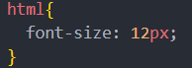

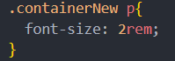

## vmin/vmax

vmin – represents the smaller dimension of viewport

this means that width: 100vmin = 100% of height (in laptop), or 100% of width in phone

vmax represents the larger dimension of viewport

this means that width: 100vmax = 100% of width (in laptop) or 100% of height in phone

vmin adapts to smaller dimension and vmax adapt to larger dimension

min-height: 60vh; -- we can put this inside the CSS of a container. This means even if that container has no content, even then the min height will be 60vh

max-width: 50%; -- if we put this in a CSS of an element it means that the width would be 50% of the parents width